How to install the project

First open the link from PowerPoint presentation, press the green button “<> Code” and then click on “Download Zip”.



Then click on the downloaded file.

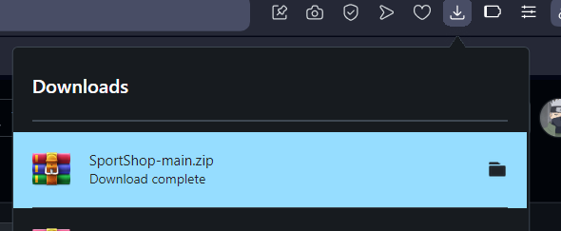

Next step select the folder and click on “Extract To” to extract the files where do you want in your computer.

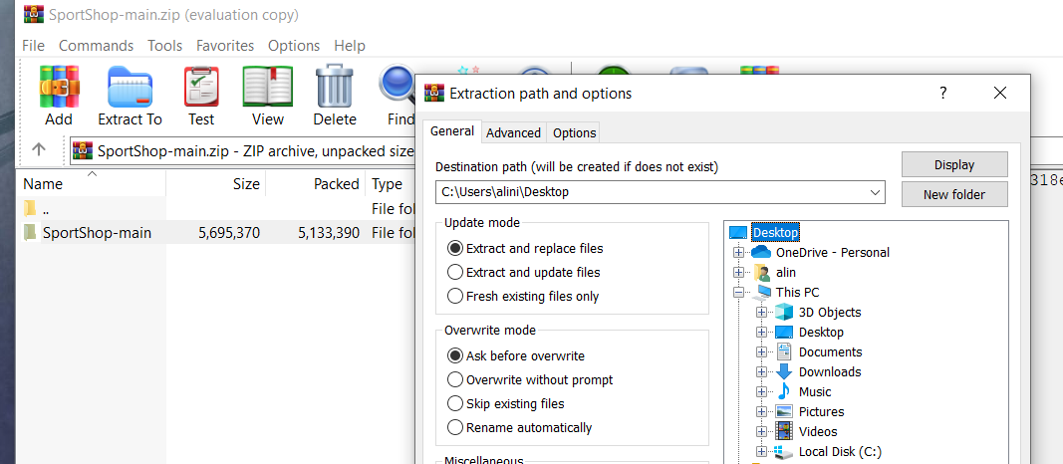

After you extract the project in your computer open your IDE and drag the folder inside your project.

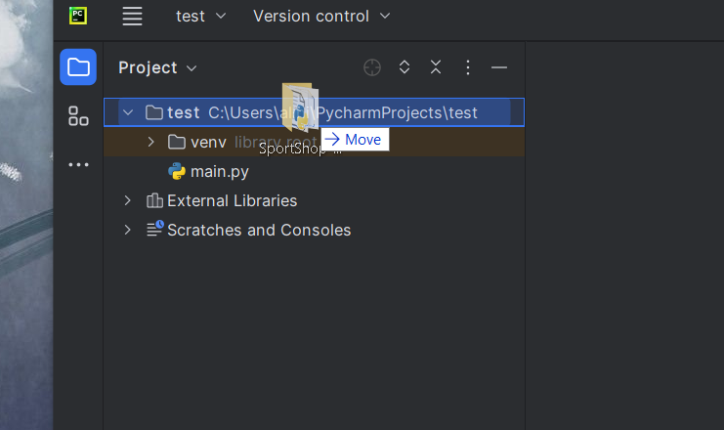

Then right click on the project name and click on “open in terminal” and insert these 5 commands:









Now you have the project copied and installed.